YIELDLENS — STABILITY-AWARE SENSOR REDUCTION FOR SEMICONDUCTOR YIELD MONITORING

1. What It Is
YieldLens is a manufacturing analytics tool that takes a semiconductor fab's sensor data (590 sensors in the SECOM dataset, but designed to generalize to any similar dataset) and answers one question:
Note: Fab Data (Fabrication Data) refers to the massive volume of metrics, logs, and sensor readings generated during the production of silicon wafers.

"Which small set of sensors can we trust to predict yield failures, reliably, over time — not just on today's snapshot?"
It does this by combining a time-aware feature stability method with a standard classification pipeline, then proves the method works with a controlled synthetic experiment, and ships as a small, real, hosted web app — not a notebook, not a slide deck.

2. Why This Project (The Problem)
Fabs collect hundreds of sensor readings per wafer, but:
- Most of those sensors are noisy, redundant, or irrelevant.
- Standard feature-importance methods (SHAP, permutation importance, plain LASSO) are computed on a single static split of the data — they tell you what mattered in that sample, not what will keep mattering as the process drifts over time.
- Engineers can't act on "sensor #47 was important" if that importance disappears next month. That's the gap between a stats exercise and something operationally usable.
Every publicly visible SECOM project (GitHub repos, WASET paper, arXiv papers) stops at static importance ranking. This project adds the one dimension most of them skip: does importance hold up over time.

3. Business Objective (End Goal)
If a fab could monitor 15 sensors instead of 590 with no meaningful loss in failure-detection accuracy, it would:
- Cut monitoring/metrology cost and data infrastructure load
- Make root-cause investigation faster (engineers check 15 dashboards, not 590)
- Make anomaly response actionable, because the shortlist is trustworthy across time, not just today
Deliverable framing: "% yield loss avoided using a 15-sensor model vs. the full 590-sensor model" — a number a plant manager understands, not just an AUC score a data scientist understands.

4. Paper / Research Objective (What We're Trying to Prove)
Hypothesis: A feature-stability score computed across chronological batches identifies a smaller, more trustworthy sensor subset than static importance ranking or bootstrap-based stability selection — with no meaningful drop in predictive accuracy.
What the paper must show, concretely:
- A reduced ~15-sensor model performs statistically comparably to the full 590-sensor model (not just "close," but tested).
- The stability score correctly identifies sensors with known injected drift as "unstable" — proof the metric measures something real, not noise.
- A clear, cited distinction from the closest existing work (RobustModelMaker, 2026 — bootstrap-based stability selection on the same dataset), positioning this project's method as temporal/drift-aware stability rather than resampling-based stability.
Limitation to state honestly in the paper (this is a strength, not a weakness, if stated): SECOM's ~1567 rows mean chronological batches are small; results should be read as a proof-of-concept for the method, not a production-ready claim, and multi-dataset generalization is future work.

5. Novelty — Precisely Stated
Existing work | What it does | Your distinction
Standard SECOM projects (GitHub, WASET) | Static importance ranking, SMOTE + RF/XGBoost, accuracy-only reporting | You add a stability dimension entirely absent here
RobustModelMaker (arXiv, 2026) | Bootstrap-resampling stability selection, leakage-safe CV, retains 308/590 features | You use chronological/time-based stability instead of resampling — a different question (drift-robustness vs. statistical robustness)
arXiv 2406.04533 | XGBoost + SMOTE + feature-voting | No stability or time dimension
One-sentence novelty statement for your paper's abstract:
"Unlike prior stability-selection approaches on SECOM that measure robustness via bootstrap resampling, this work measures robustness via chronological drift, directly targeting the operational question of whether a sensor will remain predictive over time."

6. Standout Features (kept to 2, by design — small scope, high credibility)
# | Feature | What it proves | Effort
1 | Time-based stability selection — LASSO run per chronological batch, consistency scored across batches | The core novel method | This is the project itself
2 | Drift-injection validation — synthetically shift the mean of 2–3 known features partway through the timeline, confirm the stability score flags them as unstable | The method actually works — not asserted, demonstrated | ~half a day, one script
Free bonus (not a separate feature, costs nothing extra): once importance + stability scores exist, plot them as a 2D scatter (importance × stability) — this single chart makes the entire method visually self-explanatory in a demo or viva.

7. Gaps to Close (state these, don't hide them)
As an engineering project:
- Redundancy: naive top-15 could include correlated/duplicate sensors → note as future work (correlation clustering), don't build it now.
- Small sample size for time batching → state explicitly as a limitation, not a hidden flaw.
As a paper:
- Single-dataset validation → note multi-dataset generalization as future work.
- No formal statistical significance test on the accuracy comparison → if time allows, add one bootstrap/permutation test on the AUC difference; if not, state it as a limitation.
Stating gaps explicitly, rather than hiding them, is what makes a coursework paper read as mature rather than naive.

8. Workflow / Architecture
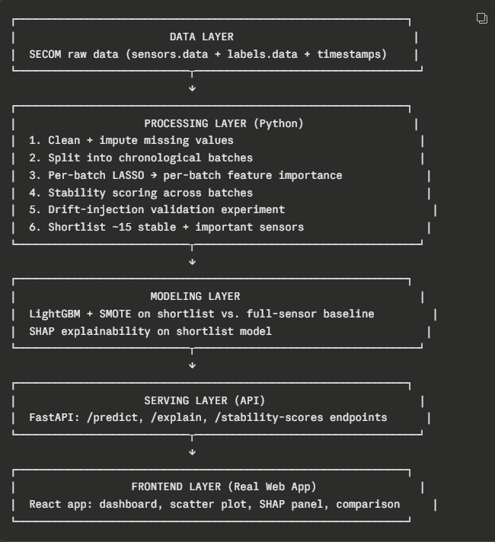

9. End-to-End Pipeline (Build Order)
Step | What you build | Output
1 | Load + clean SECOM data | Clean dataframe
2 | Chronological batch split | N time-ordered batches
3 | Per-batch LASSO importance | Importance table per batch
4 | Stability score computation | One score per sensor
5 | Drift-injection experiment | Proof the score detects injected drift
6 | Shortlist selection (~15 sensors) | Final sensor list
7 | Train baseline (590 sensors) + reduced (15 sensors) models | Two LightGBM models + comparison metrics
8 | SHAP on reduced model | Explainability values
9 | Wrap logic in FastAPI | Callable API endpoints
10 | Build React frontend | Real hosted dashboard
11 | Deploy both | Live public URL

10. Tech Stack (Real Frontend, Still Free to Host)
Layer | Tool | Why
Data processing/modeling | Python, pandas, scikit-learn (LASSO), LightGBM, imbalanced-learn (SMOTE) | Standard, well-supported, fast to run
Explainability | SHAP | Industry-standard for tree models
Backend/API | FastAPI | Real backend, not a notebook — serves predictions + stability scores as JSON
Frontend | React (Vite) + Recharts (or Chart.js) | Actual web app, not Streamlit — real component structure, real routing, looks like a product
Styling | Tailwind CSS | Fast to make it look clean without custom CSS overhead
Backend hosting | Render (free tier) or Railway (free tier) | Hosts FastAPI as a live API, sleeps when idle but wakes on request — fine for a coursework demo
Frontend hosting | Vercel or Netlify (free tier) | Deploys React app to a public URL in one command, auto-builds from GitHub
Version control | GitHub | Required for reproducibility grading
Data/query layer (optional, for the DE angle) | BigQuery Sandbox | Only if you want the SQL layer for the data-engineering skill signal — optional, not required for the app to work
This gives you a genuinely separate frontend/backend, deployed as two free-hosted services talking over a real API — a materially more "real engineering" story than a single Streamlit script, and a direct answer to interview questions about your architecture.

11. Folder Structure
yieldlens/
│
├── backend/
│ ├── app/
│ │ ├── main.py # FastAPI entrypoint
│ │ ├── routers/
│ │ │ ├── predict.py # /predict endpoint
│ │ │ ├── explain.py # /explain (SHAP) endpoint
│ │ │ └── stability.py # /stability-scores endpoint
│ │ ├── models/
│ │ │ ├── train_baseline.py # 590-sensor model training script
│ │ │ ├── train_shortlist.py # 15-sensor model training script
│ │ │ └── artifacts/ # saved .pkl model files
│ │ ├── core/
│ │ │ ├── stability.py # stability scoring logic
│ │ │ ├── drift_injection.py # synthetic drift validation experiment
│ │ │ └── preprocessing.py # cleaning, batching, imputation
│ │ └── schemas.py # Pydantic request/response models
│ ├── data/
│ │ ├── raw/ # secom.data, secom_labels.data
│ │ └── processed/ # cleaned, batched data
│ ├── requirements.txt
│ ├── Dockerfile
│ └── tests/
│ └── test_stability.py
│
├── frontend/
│ ├── src/
│ │ ├── components/
│ │ │ ├── Dashboard.jsx
│ │ │ ├── StabilityScatterPlot.jsx
│ │ │ ├── ModelComparison.jsx
│ │ │ └── ShapPanel.jsx
│ │ ├── api/
│ │ │ └── client.js # calls to FastAPI backend
│ │ ├── App.jsx
│ │ └── main.jsx
│ ├── package.json
│ ├── vite.config.js
│ └── tailwind.config.js
│
├── notebooks/
│ └── exploration.ipynb # scratch work, not the deliverable
│
├── paper/
│ ├── report.md / report.docx # your coursework paper
│ └── figures/ # exported charts for the paper
│
├── .github/
│ └── workflows/ci.yml # optional: basic test run on push
│
├── README.md
└── .gitignore

12. Domain, Learning You Need (so you're not just running code you don't understand)
Topic | Why you need it | Where to learn fast
Semiconductor yield basics (what a wafer, a fab process step, and a "fail" actually mean) | So, your report doesn't just describe ML steps with no domain grounding | A short primer read (SECOM's original paper + UCI page description)
LASSO / L1 regularization | You're using it as your importance method — understand why it zeroes out coefficients | scikit-learn docs + a 20-min explainer
Class imbalance handling (SMOTE) | SECOM is ~93%/7% pass/fail — naive accuracy is meaningless here | imbalanced-learn docs
SHAP values (game-theoretic feature attribution) | You're explaining the model with it — know what a SHAP value actually represents, not just how to call the library | SHAP's own documentation/tutorials
Time-series/chronological data splitting | Core to your novelty — understand why random splits leak information here | Any "avoiding data leakage in time series" article
Basic statistical validity (what makes a comparison "significant" vs. "looks better") | Needed to responsibly state your baseline-vs-shortlist claim | Optional but strengthens the paper

13. What "Done" Looks Like
- A public GitHub repo matching the structure above
- A live React frontend URL + live FastAPI backend URL
- A dashboard showing: stability×importance scatter plot, baseline-vs-shortlist comparison, SHAP explanations
- A written paper section that states the hypothesis, the method, the drift-injection proof, the honest limitations, and the citation-based novelty distinction from RobustModelMaker

Team assignments
Team | Owns | Deliverable
A — Data/ML | Stability selection, drift-injection proof, baseline vs. shortlist models, SHAP | Saved model files + a metrics JSON + the paper's methodology section
B — Backend/API | FastAPI wrapping Team A's models, Docker, deployment | A live API URL with /predict, /explain, /stability-scores
C — Frontend | React dashboard, charts, UI | A live web app URL consuming Team B's API

Git Workflow
- Protect the main branch – No direct commits; all changes go through Pull Requests (PRs).
- Create a feature branch – One branch per task (e.g., a/stability-scoring, b/api-predict-endpoint, c/dashboard-scatter).
- Develop and commit – Work only in your feature branch and push it to GitHub.
- Open a Pull Request – Submit your changes for review.
- Code Review – At least one teammate reviews and approves the PR.
- Merge to main – Merge only after approval.
- Use CODEOWNERS – Automatically request the appropriate reviewer for changed files/folders.

